Case 3-Asia-Indus-Venus-Bird Beak-3000 BCE

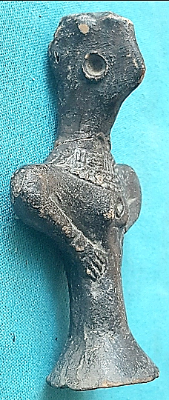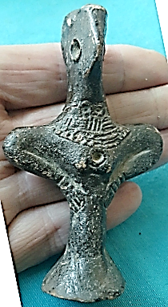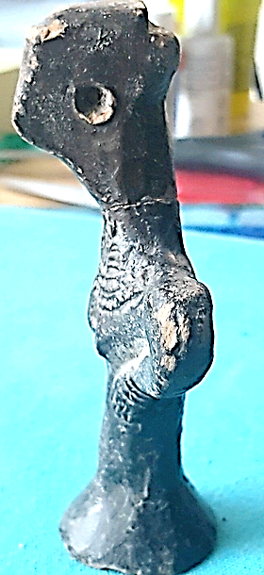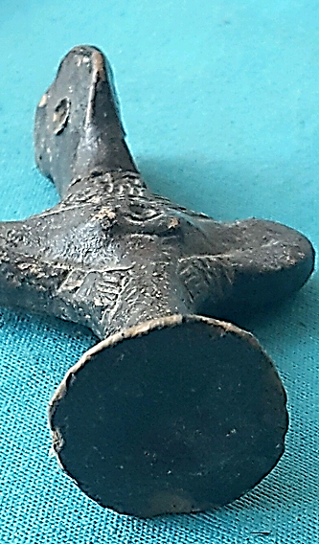

**Case no.: 3**

**Accession Number:**

**Formal Label:**

**Display Description:**

The most important discover) was the remains of a mature Ha rap pun

settlement culled Sotka-Koh—burnt hill'—situated 9 mile* north of Pasm

on the bunk of the Shadi Kaur. Its situation in the foothills of the Talor

range on an alluvial plain, and on die bank of die river, strikingly resembles

the site of Sutkagen - Dor. During the time oHo occupation by the Harappan

jjcople using their V/dt-devclopcd and characteristic ceramics, it must have

been nearer the coast and more easily accessible than it is at present. The

original coastline has been changed as a result of great geological changes.

These Harappan sites dotted along the Makran coast at Sutkagen-Dor,

Sotka-Koh, and that of Bala-Koi near Sonmiam bay, recently reported to

the Department by Mr. R. L. Ritikcs, served as outposts guarding and

-supplying the vessels sailing along the coast. The recent exploration lias

therefore provided evidence in support of the sea-mute which existed m the

Harappan times between the East ami Went. Incidentally, the discovery oi

a dockyard at the Harappan site of LothaS (India) may be mentioned as

providing additional confirmation of the results.

**LC Classification:**

**Date or Time Horizon:**

**Geographical Area:**

**Map:**

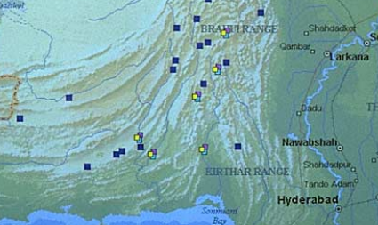

**GPS coordinates:**

**Cultural Affiliation:**

**Media:**

**Dimensions:**

**Weight:**

**Condition:**

**Provenance:**

**Discussion:**

**References:**

Estimated delivery **Friday, Jan 13, 2017** **- Thursday, Jan 19, 2017**

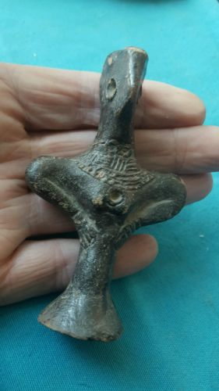

[**RARE ANCIENT INDUS VALLEY FERTILITY IDOL FROM THE HARAPPA CULTURE 3300-1200 BC**](http://www.ebay.com/itm/162342760032)

|  |  |
| --- | --- |
| Item price | $99.35 |
| Quantity | 1 |
| Item number | 162342760032 |
| Shipping service | International Tracked Postage |

Estimated delivery **Friday, Jan 13, 2017** **- Thursday, Jan 19, 2017**



[**RARE ANCIENT INDUS VALLEY FERTILITY IDOL FROM THE HARAPPA CULTURE 3300-1200 BC**](http://www.ebay.com/itm/162342760032)

|  |  |
| --- | --- |
| Item price | $99.35 |
| Quantity | 1 |
| Item number | 162342760032 |
| Shipping service | International Tracked Postage |